PHASE-XS
Clinical Trials Intelligence Platform
Project Introduction
June 2026

Introduction
The global clinical trials landscape is vast, fragmented, and difficult to navigate. Thousands of trials are registered across multiple national and international registries every year, each carrying rich information about drugs, molecules, patient populations, trial designs, and outcomes — yet this data remains locked in disparate sources with no unified view.

PHASE-XS is built to change that. It is a secure, intelligence-driven platform that aggregates, structures, and surfaces clinical trial data from the United States, India, and the United Kingdom into a single interactive dashboard — giving pharmaceutical researchers, biotech teams, and medical professionals the clarity they need to make faster, better-informed decisions.

What Are We Trying to Do?
We are building a centralised clinical trials intelligence tool that makes it easy for anyone in the pharmaceutical and biotech ecosystem to explore, filter, compare, and analyze clinical trial data across geographies — all in one place, with no manual data wrangling required.

Specifically, PHASE-XS enables users to:

• Search trials by molecule, indication, sponsor, trial ID, or free text
• Filter by phase, drug technology, trial design, route of administration, and recruitment status
• View real-time KPI metrics — enrollment, duration, adherence, drug pricing
• Explore visual analytics — phase distribution, technology breakdown, timeline trends, top indications
• Drill into individual trials for a full profile and download a PDF report
• Compare sponsors, molecules, or indications side by side
• Switch seamlessly between US (NCT), India (CTRI), and UK (ISRCTN) registry data

The Problem We Are Targeting
Clinical trial data is publicly available — but practically inaccessible. The core problems faced by researchers and pharma teams today are:

Problem | Impact
Fragmented data sources | US, India, and UK registries are separate systems with no cross-registry view, forcing researchers to check multiple databases manually
No analytical layer | Raw registry data offers no KPIs, no charts, no aggregations — users must download CSVs and build their own analysis
Time-intensive research | Identifying competitive landscapes, dominant technologies, or enrollment trends across hundreds of trials can take days
No comparison tool | There is no native way to compare two sponsors, molecules, or indications head to head using registry data
Limited accessibility | Registry interfaces are functional but not built for exploratory research or non-technical users
Geography blindspots | Most teams focus only on US (ClinicalTrials.gov) data, missing significant activity in India and the UK

What Is the Resultant Outcome?
PHASE-XS transforms raw, scattered registry data into actionable intelligence. The outcomes for users are:

For Researchers & Scientists:
• Instant access to structured trial data across three registries without any manual lookup
• Ability to identify competitive landscape for any molecule or indication in seconds
• Trend visibility — which phases, technologies, and conditions are growing year over year

For Pharma & Biotech Teams:
• Benchmarking tool for comparing enrollment sizes, trial durations, and adherence across sponsors
• Drug pricing data and adherence rates surfaced alongside trial characteristics
• PDF trial reports for use in presentations, regulatory submissions, and internal reviews

For Strategic Decision-Making:
• A single dashboard to assess which geographies are most active for a given indication
• Clear view of technology dominance (mAb vs ADC vs CAR-T vs Bispecific) by phase and market
• Evidence-based insights to prioritise trial design, partnership, or licensing decisions
How It Is Done — Technical Overview
PHASE-XS is a full-stack web application built on modern, production-grade technologies. The system has three layers: data ingestion, backend API, and interactive frontend.
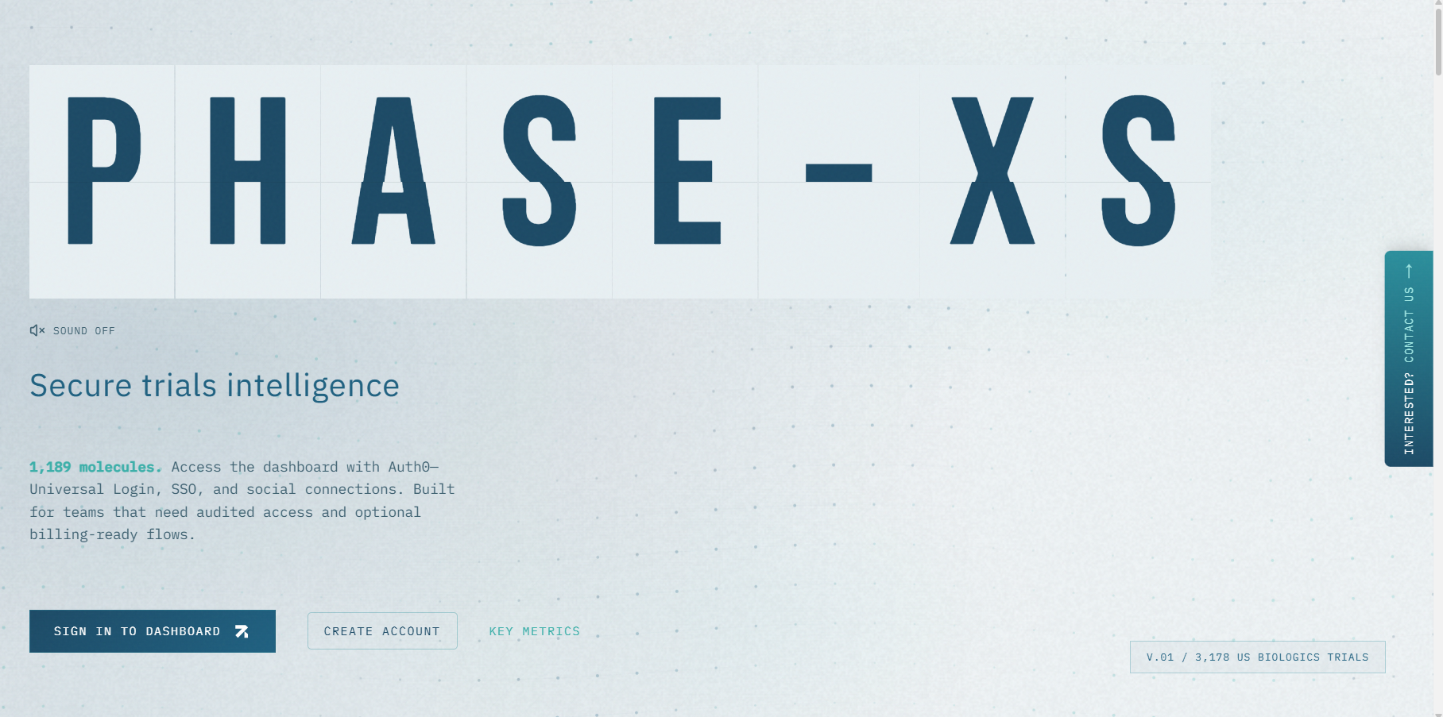

1. Data Layer
Clinical trial data from three registries is imported into a PostgreSQL database using custom TypeScript scripts:
• append-uk-to-postgres.ts — imports UK cancer trials from ISRCTN exports
• append-ctri-to-postgres.ts — imports Indian trials from CTRI files
• sync-trials-from-xlsx.mjs — imports US trials from ClinicalTrials.gov exports
Database indexes are created on key fields (trial ID, molecule, phase, indication, sponsor) to ensure fast query performance even across large datasets.
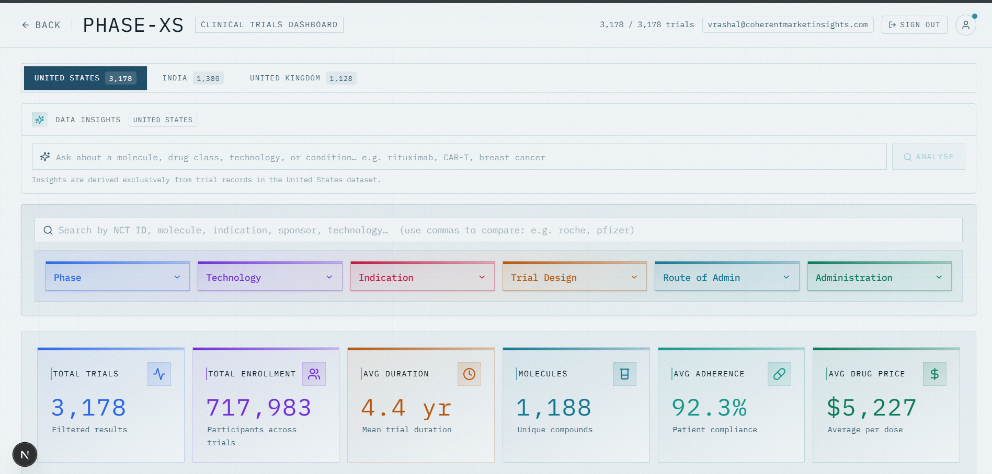
2. Backend API
The backend is built with Next.js 16 App Router, using Server Components and API Routes:
• dashboard-query.ts — builds parameterised SQL queries from active filters and returns KPIs, chart data, and paginated table rows in a single call
• dashboard-region.ts — defines region profiles (US / India / UK), each specifying its own table, columns, KPI set, and chart configuration
• insights-query.ts — generates contextual insight summaries from aggregate query results
• trial-detail-db.ts — fetches full trial detail records for the slide-over panel and PDF export
Auth0 middleware protects all dashboard routes, redirecting unauthenticated users to the login flow.

3. Frontend Dashboard
Built with React 19 and Tailwind CSS, the dashboard is fully interactive and server-side rendered for fast initial loads:
• Filters, search, and region tab state are managed client-side and trigger server fetches on change
• Recharts renders all analytics charts (pie, bar, area) with live data bound to the current filter state
• The trial detail sheet is a Radix UI sheet component loaded on row click, with jsPDF generating downloadable reports
• Framer Motion and GSAP power the landing page animations, including the split-flap trial count display
Graphs
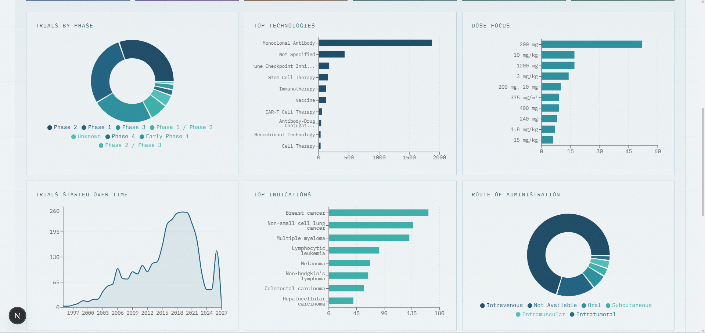
Trial Records
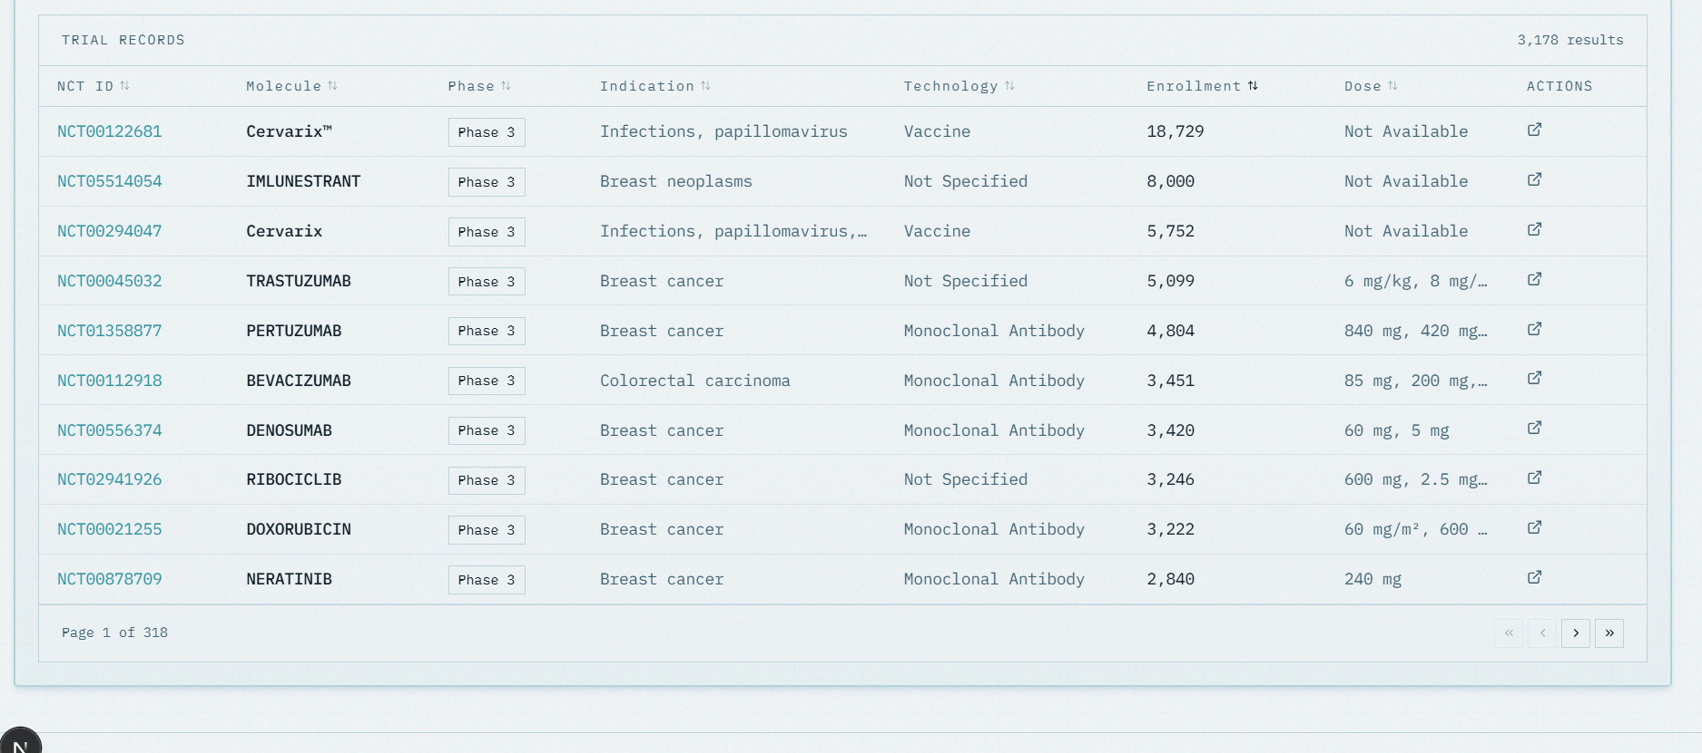
Report View
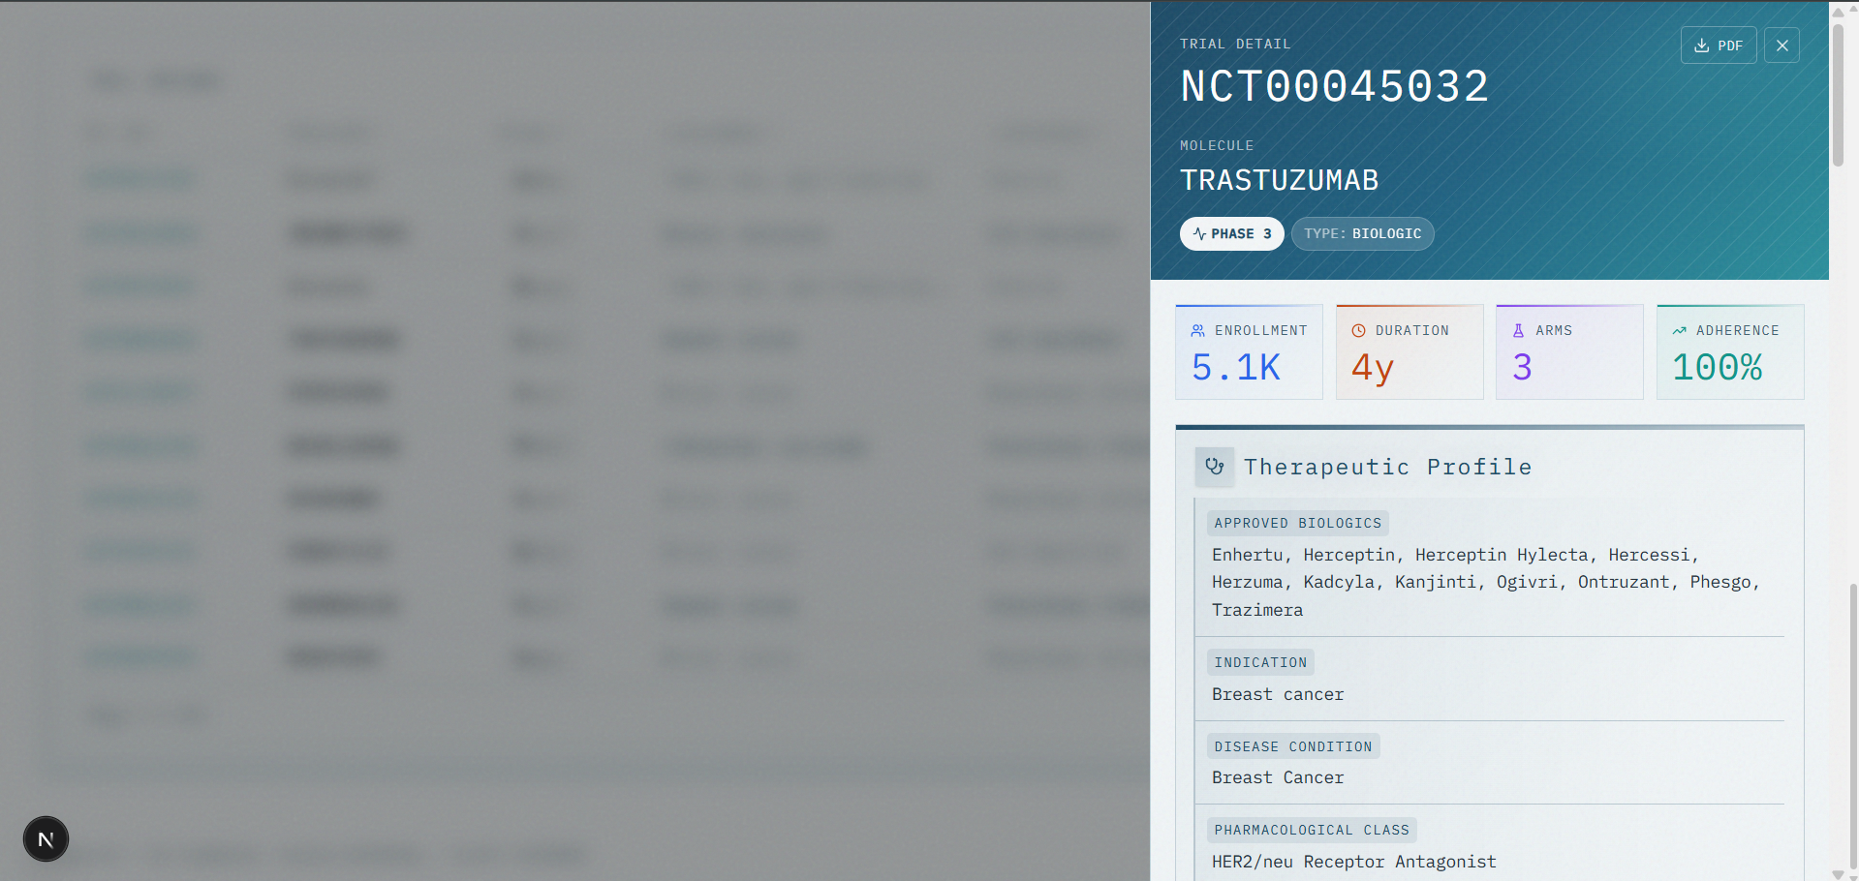
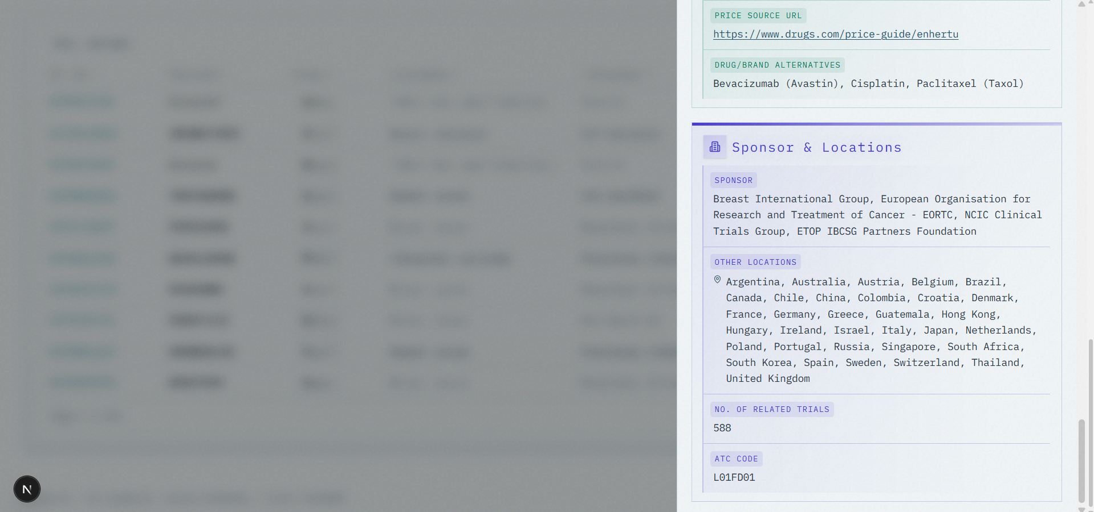
Insights
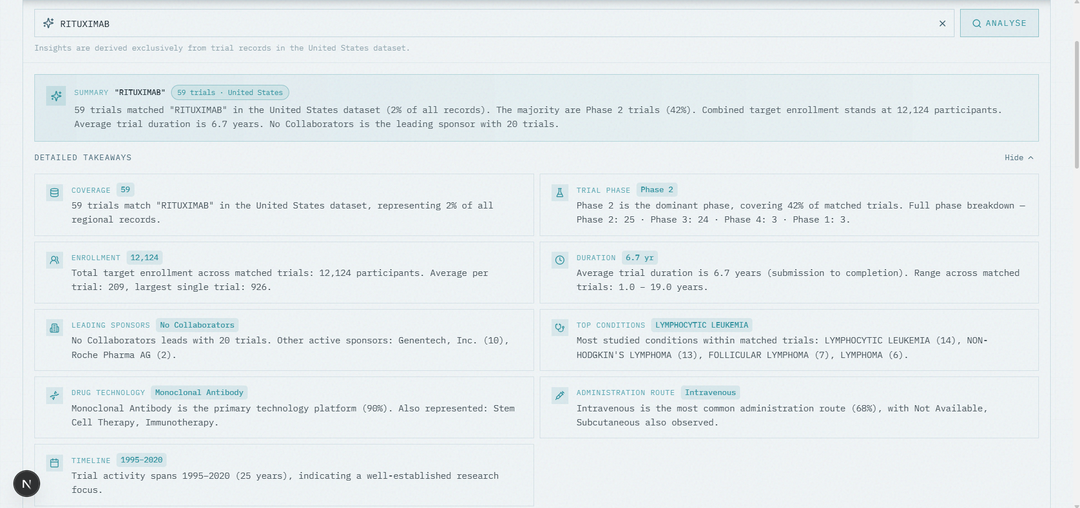

4. Infrastructure & Security
• Deployed on Vercel with edge-optimised Next.js server functions
• Auth0 Universal Login handles authentication, supporting email/password and social SSO
• Cloudflare Turnstile protects the public contact form from bot abuse
• Nodemailer handles transactional email notifications

Technology Stack at a Glance
Layer | Technology
Frontend | Next.js 16, React 19, TypeScript, Tailwind CSS
Charts | Recharts
Animations | Framer Motion, GSAP
Database | PostgreSQL
Authentication | Auth0
PDF Generation | jsPDF
Deployment | Vercel

PHASE-XS · Project Introduction · June 2026

